EVERYDAY WEATHER NOTES:

Everyday Weather Notes
This is the page of notes I took in with me for the 2010 Michigan regional Meteorology event. The topic of the event was Everyday Weather.
- 'High Clouds

  - Cirrocumulus – Above 20,000 feet. Sometimes releases precipitation, but may be virga. Appears as small patched clouds in rows.
  - Cirrus – Above 23,000 feet. Not a cloud that releases precipitation. Appears as thin, wisp-like strands.
  - Cirrostratus – Above 20,000 feet. Not a cloud that releases precipitation, but may appear before rain that happens in the next 12 to 24 hours, since these clouds may signal the beginning of a warm front.
- Middle Clouds

  - Altostratus – 8,000 to 20,000 feet. Rain showers are possible in thickened clouds. If rain becomes persistent, clarification becomes nimbostratus. Appears as sheet or layer, you can usually see the sun through it.
  - Altocumulus – 8,000 to 20,000 feet. Not a precipitation cloud, but often signals an oncoming thunderstorm soon or later in the day if it appears in summer. Appears as large, dark patched clouds. Often seen before a cold front.
- Low Clouds
  - Cumulus – Base below 6,500 feet. Can be a a precipitation cloud, but may be virga. Has a puffy appearance.
  - Stratocumulus – Usually below 8,000 feet. Appears lumpy, darker than most clouds, and in layers. Is a precipitation cloud but never intense. May indicate an oncoming storm.
  - Nimbostratus – Below 8,000 feet. Appears dark, widespread, formless layer. Is a precipitation cloud but may be virga.
  - Stratus – Below 6,000 feet. Appears in horizontal layers. It is a precipitation cloud, but usually minor precipitation.
- Vertical Clouds

  - Cumulonimbus – 6,000 to 60,000 feet. Very tall and large. Is a precipitation cloud and often is intense, but may be virga. May develop into a supercell, which is a severe thunderstorm with special features.
  - Cumulus (See Low Clouds)
  - Pyrocumulus – Dense, associated with fire or volcanic activity. Appears as a gray or brown color because of the volcanic activity, and the cloud is puffy. The cloud can trigger a thunderstorm and/or lightning.
- El Nino:
  - - Rise in surface pressure over the Indian Ocean, Indonesia and Australia.
  - - Fall in air pressure over Tahiti and east/central Pacific Ocean.
  - - Warm water spreads from the west Pacific and the Indian Ocean to the east Pacific. It takes the rain with it, causing extensive drought in the western Pacific and rainfall in the normally dry eastern Pacific.
  - - Warm air rises near Peru, causing rain in the north deserts.
  - - Trade winds in the South Pacific weaken or head east
  - - Reduces hurricane activity.
  - - Occurred in 1997-1998.
  - - Causes more snowfall.
- LA NINA IS THE OPPOSITE OF EL NINO!
- Nephology – the study of clouds and cloud formation.
- Cloud cover – the amount of sky obscured by clouds in a particular location
- Cloud seeding – the attempt to change or convert the type of precipitation falling from a cloud
- Weather lore – the folklore related to the prediction of the weather
- Albedo – a measure of a fraction of reflected incident sunlight
- Virga – the precipitation falling from a cloud that evaporates before it hits the ground
- Sundogs – a phenomenon that creates the illusion of a “mock sun” or a bright ring or halo, on either side of the sun. They can be seen in any season in any place.
- Rainbows – a meteorological phenomenon that causes a spectrum of light to appear in the sky when the sun shines onto droplets of moisture in earth's atmosphere, taking the form of a multicolored arc.
- Aurora – Sometimes called the “northern lights”, aurora is a natural light display in the sky; the result of the emissions of photons in the earth's upper atmosphere.
- Crepuscular rays -these are rays of sunlight that appear to radiate from a single point in the sky. These are really just columns of sunlit air separated by darker cloud-shadowed regions.
- Green flash – Optical phenomenon occurring before sunrise or after sunset, when a green spot is visible in the sky for a second or two. They are caused by a refraction of light in the atmosphere, light moves slower in the thinner air, and sunlight rays curve slightly, creating an illusion of a green flash.
- Jet stream – Fast flowing, narrow air currents found in the atmosphere of planets
- Chinook winds – Foehn winds in the interior west of North America
- Coriolis effect – The apparent deflection of objects visually.
- Alberta clippers – A fast moving, low pressure area affecting Canada and the Upper Midwest between December and February.
- You can lose control of your car in six inches of water.
You should leave your vehicle if you are in a flash flood. Lightning occurs in ALL thunderstorms. Hail results in $1 billion in damages per year.
- Derecho – A long-lived, violent thunderstorm associated with a fast-moving band of severe thunderstorms.
- Doppler radar – Radar to produce data about objects at a distance. It does this by beaming a microwave signal towards a desired target and listening for its reflection, then analyzing how the original signal has been altered by the object that reflected it.
- Isobar – A line of equal or constant pressure on a graph, plot, or map.
- Air mass – A large volume of air defined by its temperature and water vapor content.
- Weather front – A boundary separating two masses of air of different densities.
- Cold front – The leading edge of an advancing mass of cold air. When it encounters a mass of less dense warm air, instability results, often triggering heavy rain.
- Warm front – The leading edge of an advancing mass of warm air. When it meets a stationary cold air mass, the warm air rises and cools. Condensation may follow, forming clouds, and usually producing widespread precipitation.
- Occluded front – An occluded front is formed when a cold front overtakes a warm front.
- Stationary front – A non-moving or stalled boundary between two air masses, neither of which is strong enough to overtake the other.
- Squall line – A line of severe thunderstorms that can form along or ahead of a cold front. It contains heavy precipitation, frequent lightning, hail, strong straight-line winds, and possibly tornadoes.
- Albedo – How strongly an object reflects light from sources such as the sun.
- Meteograms -a time cross-section that produces and uses data for a specific weather station on the ground
- Radiosondes - a unit for use in weather balloons that measures various atmospheric parameters and transmits them to a fixed receiver.

- Exosphere
The outermost layer of Earth's atmosphere extends from the exobase upward. Here the particles are so far apart that they can travel hundreds of km without colliding with one another. Since the particles rarely collide, the atmosphere no longer behaves like a fluid. These free-moving particles follow ballistic trajectories and may migrate into and out of the magnetosphere or the solar wind. The exosphere is mainly composed of hydrogen and helium.
- Thermosphere
Temperature increases with height in the thermosphere from the mesopause up to the thermopause, then is constant with height. The temperature of this layer can rise to 1,500 °C (2,730 °F), though the gas molecules are so far apart that temperature in the usual sense is not well defined. The International Space Station orbits in this layer, between 320 and 380 km (200 and 240 mi). The top of the thermosphere is the bottom of the exosphere, called the exobase. Its height varies with solar activity and ranges from about 350–800 km (220–500 mi; 1,100,000–2,600,000 ft).
- Mesosphere
The mesosphere extends from the stratopause to 80–85 km (50–53 mi; 260,000–280,000 ft). It is the layer where most meteors burn up upon entering the atmosphere. Temperature decreases with height in the mesosphere. The , the temperature minimum that marks the top of the mesosphere, is the coldest place on Earth and has an average temperature around −100 °C (−148.0 °F; 173.1 K).
- Stratosphere
The stratosphere extends from the tropopause to about 51 km (32 mi; 170,000 ft). Temperature increases with height, which restricts turbulence and mixing. The , which is the boundary between the stratosphere and mesosphere, typically is at 50 to 55 km (31 to 34 mi; 160,000 to 180,000 ft). The pressure here is 1/1000th sea level.
- Troposphere
The troposphere begins at the surface and extends to between 7 km (23,000 ft) at the poles and 17 km (56,000 ft) at the equator, with some variation due to weather. The troposphere is mostly heated by transfer of energy from the surface, so on average the lowest part of the troposphere is warmest and temperature decreases with altitude. This promotes vertical mixing (hence the origin. The troposphere contains roughly 80%[ of the mass of the atmosphere. The tropopause is the boundary between the troposphere and stratosphere.
- Stuve diagram – one of four thermodynamic diagrams commonly used in weather analysis and forecasting. Temperature and dew point are plotted on these.
- Wind shear – a difference in wind velocity over a short distance. Severe thunderstorms require this, as do supercells and squall lines.
- Energy budget - The Earth’s Energy Budget is determined by the amount of incoming energy and the amount of outgoing energy. Nearly all of Earth’s incoming energy (99.98%) is from solar radiation. About .013% comes from geothermal energy that is created by the radioactive decay of Earth’s core. About .002% of Earth’s incoming energy comes from the action of tides caused by the interaction of Earth with the Sun and Moon. Waste heat energy from fossil fuel consumption accounts for about .007% of Earth’s Energy Budget. The Earth has an average albedo of about 30% which means that ~30% of incoming solar radiation is radiated back into space before it reaches Earth's surface. After the 30% the atmosphere absorbs 19% and the earths surface absorbs 51%

CLOUD CATEGORIES

Categories:

Clouds
Cloud Pic | Name | description
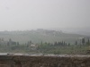 | Stratus Cloud | low clouds,Below 2,000 m. gray fog like clouds, flat
 | Stratocumulus | low-level clouds that develop below 2,000 meters that generally appear as low, lumpy layers of clouds.  usually fair-weather clouds sometimes accompanied by low-intensity precipitation such as drizzle. vary in color from dark to light gray with breaks of clear sky in between them
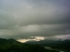 | Nimbostratus | dark, low level (below 2,000 meters) clouds that are usually accompanied by light to moderately falling levels of precipitation.  thick enough to block out the Sun entirely(gloomy day clouds) In the winter months they may also contain ice particles and snow.
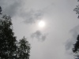 | Altostratus | gray/blue gray cloud covers entire sky over large area
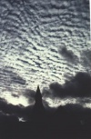 | Altocumulos | ppear as parallel bands or perhaps as rounded masses at medium altitudes (2,000-6,000m)  white, fluffy appearance (commonly nicknamed ‘sheep-back’ clouds because of their wooly appearance) usually form by the convection of air in an unstable layer aloft because of the gradual lifting of air in advance of an approaching cold front
 | Cirrostratus | sheet-like, high level clouds  composed of ice crystals. Cirrostratus clouds can cover the entire sky and be up to several thousand feet thick relatively transparent as the Sun and Moon can easily be seen through them. often form when a broad layer of air is lifted by a large-scale convergence as shown in the diagram below. Cause of halos
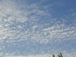 | Cirrocumulus | round white puffs
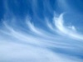 | Cirrus | Cirrus clouds are found at high altitudes (greater than 6,00 meters) and appear as thin and often wispy sheets with a feathery appearance. Cirrus clouds are usually composed of ice crystals that originate from the freezing of super cooled water droplets. Cirrus clouds are usually fair weather clouds and point in the direction of air movement at their elevation.
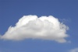 | Cumulus | looks like a piece of floating cotton life span of around 40 minutes
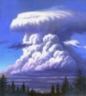 | Cumulonimbus | thunderstorm cloud forms by Cumulus cloud growth  convective updrafts sometimes at speeds of over 50 knots
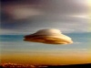 | Lenticular Cloud | A lens shaped cloud
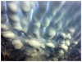 | Mammatus Clouds | baggy clouds  seen after thundersttorms can mean tornadoes
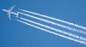 | Contrails | Jet produced clouds trail of water vapor
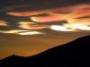 | Nacreous Clouds | soft pearly looking
Great Cloud page http://ww2010.atmos.uiuc.edu/(Gh)/guides/mtr/cld/cldtyp/home.rxml
Great Cloud book is "The cloud book: how to understand the skies" by Richard Hamblyn

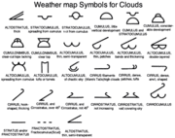
Clouds symbols

Phenomena
There are many weather phenomena here they are the major ones
Phenomena
Name | Description
Mirages | occur when light is refracted to produce an image of an object or the sky where it is not.
Haloes | Like rainbows, haloes are formed around the Sun due to moisture being refracted from the Sun’s rays in the upper atmosphere.
Belt of Venus | occurs during dusty evenings when a band of pinkish or brownish sky will appear between the sky and the horizon.
Aurora Borealis | charged particles from the Sun that have reached the Earth’s upper atmosphere and become excited
Mammatus Clouds | are often associated with a storm front
St Elmo’s Fire | luminous plasma that appears like fire on objects, such as the masts of ships or lightning rods, in an area that is electrically charged during a thunderstorm
Green Ray | occurs very briefly before total sunset and after sunrise.
Fire Rainbow | A fire rainbow is an extremely rare phenomenon that occurs only when the sun is high allowing its light to pass through high-altitude cirrus clouds with a high content of ice crystals.

Lightning
Usually associated with thunderstorms and comes from the development of cumulonimbus clouds.
The first process in the generation of lightning however is the ejection of charged particles from the sun called the solar wind, causing the Earth to acquire an electric charge in the upper layers of its atmosphere, particularly the ionosphere. This charge attempts to neutralize itself through any available path. Lightning occurs when there is a charge separation in a cumulonimbus cloud. As a thunderstorm grows, electrical charges build up within a cloud with the positive charges above the ground and the negative charges at the bottom of the cloud. The attraction between the positive and negative charges of the cloud becomes strong enough to overcome the air’s resistance to electrical flow. This sends a strong shaft of negatively charged air towards the ground where a spark surges up from the ground towards it. As they race towards one another, they connect, completing the electrical circuit that allows the flow of electrons. Most lightning strikes last about a quarter of a second.

Weather Technology

Instruments
Instrument | Uses
Actinometer | measures solar radiation
Barometer | measures pressure
Barograph | used to make a continuous recording of atmospheric pressure
Ceilometer | record ceiling
Evaporimeter | measures evaporation of water
Hygrometer | measures moisture content of gases/gas
psychrometer | measures relative humidity
radiosonde | group of instruments for measurement and radio transmission of
rawinsondes | unit for use in weather balloons that measures various atmospheric parameters and transmits them to a fixed receiver
rain gauge | measures rainfall
thermometer | measures temperature
Wind vane | show wind direction

Forcasting
There are many ways to forecast, but the simplest way is to take today's weather and say that tomorrow is going to be the same. This can be called the Persistence method.
The next method can be called the trends method it relies on mathematics to forecast. This method involves being able to get a accurate measerment of the speed at which the weather system is moving and putting the numbers into(S=d/t) and determining the time at which the system will be at your position. Here is an example of the trend model:
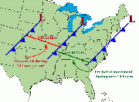
trend model
The Climatology Method is another easy way of forecasting. This method involves averaging weather statistics accumulated over many years to make a forecast.
The Analog Method is a more complicated method of producing a forecast. It involves examining today's forecast scenario and remembering a day in the past when the weather scenario looked very similar. Than you would predict that the weather in this forecast will behave similar to the day in the past.

Radar
Before we get into any satalite imagery or the like you need to know Radar.
Radar is a very important part of todays Meteorologists it gives us a chance to have early warning of approaching storms and rain so lets start with the basics

Radar Basics
Radar is a simple concept, you have a beam you send out and it reflects back to an antennae that collects the beam and sends it via wire to a reciever. the return signals are arranged to produce a radar image.
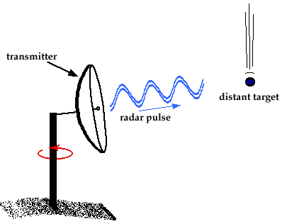
Radar transmitting
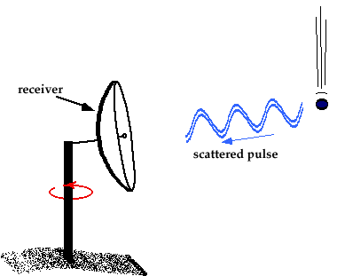
Radar Recieving

So when the Beam of energy (electromagnetic) hits it target it is reflected in all directions some going up some going down some going back toward its origin point we are only really interested in the returning energy. This returning energy is much weaker when it is returning than when it left. The size of the reflecting particle determines the strength of the return signal this means that the larger the particle the stronger the signal and the smaller the particle the weaker the signal. Also the more particles there are the stronger the return signal because the returning beams combine to form a stronger signal
The amount/size of the reflectivity is proportional to the number and size of the drops encountered by the electromagnetic pulse. Because of this high reflectivity normally means heavy precipitation while low reflectivity means lighter precipitation.

Wavelengths
Since Radar uses electromagnetic pulses or electromagnetic waves so that means that wavelength will affect the signal and pulses. The two wavelengths are short and long wavelengths. Short wavelengths are good at measuring small particles like dust and cloud droplets. However the short wavelength also makes this wavelength easily absorbed by the the materials it reflects off of (this is called attenuation). This feature makes it hard to measure disant targets.
Long wavelengths have the advantage that absorption by the particles is reduced this feature makes this wavelength very useful for looking at severe storms and other large scale/distance weather. Long wave radar are what is used im nost Dopplar radars like the National Weather Service's WSR-88D Doppler radars

How To read weather maps/satellite imagery
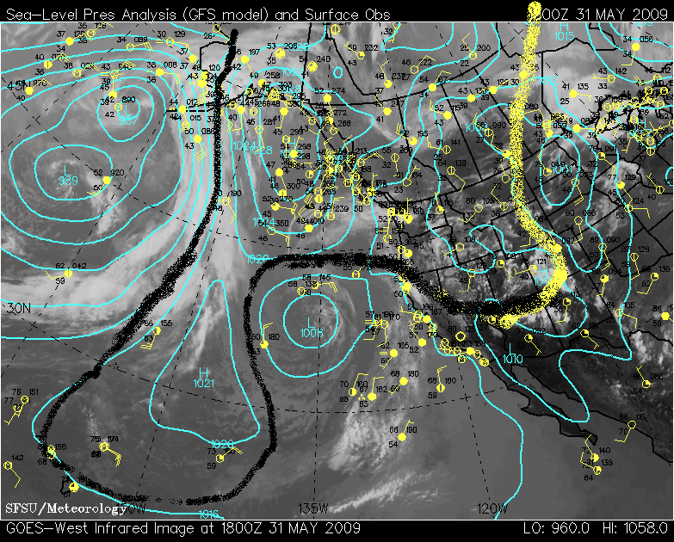We are going to start off with the very basic weather map the kind that you will most likely see at competition:
- Start by identifying the different pressure zones on the map. Above it is already done but if it wasn't marked look for sections that have a circle with a very high or low pressure.
- Look for fronts. This can be done by looking at the station ball symbols. (those are the yellow circles with the tails the tails indicate wind direction) look and find a sudden change in wind direction/pressure that will normally indicate a front. I marked where I believe a front to be.
There are many lines on this map. Each one means something:
- The blue lines are isobars which mean that they are lines of constant pressure.
- The yellow circles with "tails" are called station ball symbols of station models; they are explained in the next section.
Something else you might see on a weather map is a isotherm, which is a line of constant temperature.

Station Models
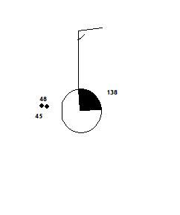
This image is a station model. It can tell you many different things, like wind speed, wind direction, temperature, dew point, current weather, cloud cover, and pressure, given that you know how to read and interpret it. Some symbols have more information than others on them, but here is a basic overview:
- The 48 is the current temperature
- The 45 is the dew point
- The "whatever" that is in between the two numbers is the current weather. On this one it is a light rain.
This is what tells you information about the wind. The direction the stick faces shows the wind direction, and how many lines on the end of it show the wind speed. A half line signifies five knots, a full line ten knots, and a bold line 50 knots.
This indicates how much cloud cover there is. There are nine choices:
cloud Cover
Picture | Meaning | Picture | Meaning | Picture | Meaning | Picture | Meaning | Picture | Meaning | Picture | Meaning
 | Clear |  | 1/8 |  | 1/4 |  | 3/8 |  | 1/2 |  | Missing
 | 5/8 |  | 3/4 |  | 7/8 |  | overcast |  | Obscured

Symbols
this is from here:http://www.sover.net/~redcamp/wxplegend.gif

METAR
This is a way that meteorologists convey what is happening at a point on Earth. It is a very abbreviated language. Here is an example of METAR:
KCLL 312253Z 14007G15KT 10SM CLR 31/15 A2990 RMK AO2 SLP120 T03110150
all of this means something, you just have to know what the abbreviations mean.
METAR
Abreviation | Explanation | What is says
KCLL | this tells you where the METAR station is located
312253Z | this tells you the date and time in zulu* | this says that it is the 31st of the month and is 22:53 zulu
14007G15KT | wind direction and speed | this says that the wind is from 140degrees at 7kt with gusts to 15 kts
10SM | visibility | this says there are 10 statute miles of visibily
CLR | clear skies
31/15 | temperature and Dewpoint in Celsius
A2990 | inches of mercury(29.90) | to get millibars multiple by 33.863
RMK | Remarks | this is where the station will post claritive data
A02 | type of automated station | AO1; automated station without a precipitation descriminator. AO2; automated station with precipitation discriminator
SLP120 | sea level pressure
T03110150 | acually temperature | this says that the temperature is actually 31.1 and the dewpoint is 15
Zulu is a time measurement based off of a 24-hour clock
here is a more in depth METAR guide: http://www.met.tamu.edu/class/metar/quick-metar.html

Stuve Diagrams
A Stuve diagram is the compilation of data gathered in Weather Balloon flights
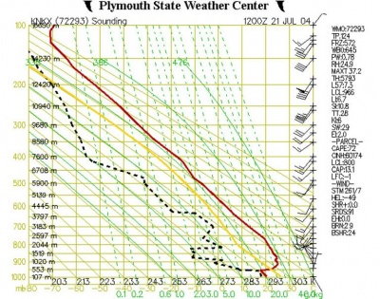
As you can see the image above is extremely cluttered and hard to understand so lets break it down.

altitude.
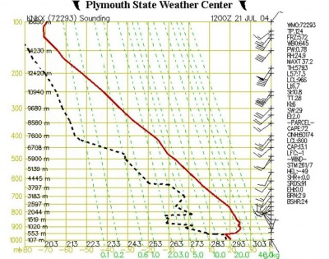
As you can see more information has been added the dashed green lines and the dashed Black line
The dashed green line shows represents the saturation mixing ratio which is the amount of water vapor needed in a parcel of air ( the amount needed to make a cloud)
The Black line shows how temperature of Dew Point changes with altitude
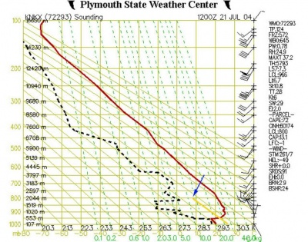
Since it makes it more interesting lets add yet more elements to this chart. These are the Yellow line and also the Solid diagonal lines.
The yellow line show the temperature of a parcel of air as it is moved through the atmosphere The solid diagonal lines are called dry adiabats and show the rate at which unsaturated of dry air will cool down as it rises up through the atmosphere. at a rate of about 10˚C/km.
If an air parcel is initially unsaturated it will cool off at the dry adiabatic lapse rate as it rises (note that the yellow line is parallel to the solid diagonal lines).
So let us assume the parcel of air starts off at an altitude of 500m (with a temperature of 22˚C. If it then gets lifted up it will cool off at 10ºC for every km it rises. This is shown by the yellow line. At an altitude of 2000m it will have cooled to a temperature of about 7˚C. At this point it has cooled down enough that it is now saturated.
Why does this happen you ask ?
Remember that we can find out the saturation mixing ratio for any temperature and pressure from the dashed green lines on the graph. Well, at 800 mb and 7˚C (where the yellow line ends) the dashed green line which would go through this point would have a value of 8 g/kg. This is the saturation mixing ratio for this point. But this was also our actual mixing ratio for this air parcel. So now the air has cooled down enough that the actual mixing ratio is the same as the saturation mixing ratio. The altitude at which this happens is the lifting condensation level (LCL). This is the point at which moisture contained in a rising parcel of air can begin to condense. this is shown in the list of data at the right-hand side of the figure. Look under “PARCEL”, then find “LCL:800”. This indicates that the lifted air parcel would reach its lifting condensation level at 800 mb.
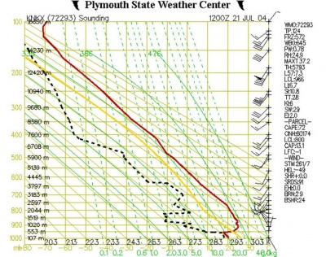
so we finally have amde it to the last part of the broken up stuve diagram. they are the solid green lines which we refer to as saturated adiabats. These show the rate at which saturated air cools as it rises.
The lines are somewhat curved because the saturated adiabatic lapse rate fluctuates between 2˚C/km to nearly 10˚/km(the dry adiabatic lapse rate), depending moisture content of the parcel of air
images above come from this site

Meteograms
A meteogram is a mix of station ball symbols and metar
The graph along the top of the Meteogram shows temperature and Dew point. temperature is the top line(green) and dew point is the bottom line (blue)
The abreviation EXTT (extreme temperature) shows the maximum and minimum temperatures which are plotted below the chart at specific reporting times. 12Z and 18Z are generally low temperatures and 0Z and 6Z are high temperatures.
The WX shows the current weather data at the time of data collection
SNWDP would show snow-depth if there where any.
PREC would tell you precipitation in inches
VIS tells you visability in miles
WGST would tell you windgusts
WIND (winds and cloud cover) - This is same sympols wind and cloud cover symbols used in the station models
Cloud chart will give cloud layer information. The vertical axis is height of cloud base in feet. The layers are plotted as horizontal lines.
- Clear skies are plotted as a 'C'. S
- cattered cloud layers (1/8th to 3/8th coverage) are plotted as a single short dash.
- Broken cloud layers (4/8th to 7/8th coverage) are plotted as two short dashes. *Overcast layers are plotted as a single long dash.
The actual cloud ceiling is displayed below the chart in 100s of feet if the ceiling is below 10,000 feet.
Pressure chart - This chart plots sea level pressure (or altimeter setting if pressure not reported) in millibars.

Beaufort Scale
Beaufort Scale
Force | Wind Speed(knots) | Classification | Appearance | Picture
0 | >1 | Calm | Calm, smoke rises vertically | 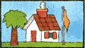
1 | 1-3 | Light Air | Smoke drift indicates wind direction,wind vanes still
2 | 4-6 | Light Breeze | Wind felt on face, leaves rustle,wind vanes begin to move
3 | 7-10 | Gentle Breeze | Leaves and small twigs constantly moving, light flags extended
4 | 11-16 | Moderate Breeze | Dust, leaves, and loose paper lifted, small tree branches move
5 | 17-21 | Fresh Breeze | Small trees begin to sway
6 | 22-27 | Strong Breeze | Larger tree branches moving, whistling in wires
7 | 28-33 | Near Gale | Whole trees moving, resistance felt walking against wind | 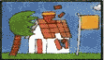
8 | 34-40 | Gale | Whole trees in motion, resistance felt walking against wind
9 | 41-47 | Strong Gale | Slight structural damage occurs, slate blows off roofs
10 | 48-55 | Storm | Seldom experienced on land, trees broken or uprooted, "considerable structural damage" | 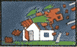
11 | 56-63 | Violent Storm
12 | 64+ | HURRICANE | lokk up the great hurricane of 1900(see also katrina) | 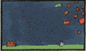

Referance

